# **Kinds of Binary Trees**

## **Perfect Binary Tree**

* A **perfect binary tree** is a type of binary tree in which

1. **All nodes have exactly two children**
2. **All the leaf nodes are at the same level**

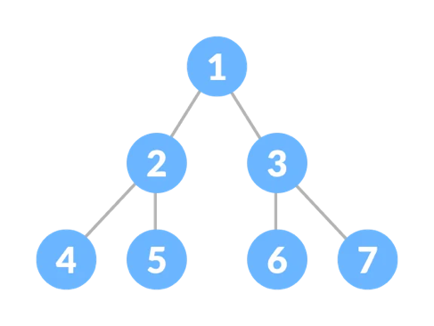

### **Number of Nodes**

* A perfect binary tree of height *h* has the following properties:
  + 2*h* total nodes at **current level** *h* (number of nodes only on this row)
  + 2*h+1* − 1 total nodes **up to level *h*** (number of nodes in this and all previous rows)
* If we traverse down the tree from the root to the leaves, we see that at every level, the number of nodes double.
  + Level 0 has 1 node.
  + Level 1 has 2 nodes.
  + Level 2 has 4 nodes.
  + and so on…
* From this, we can see a pattern.
* The number of nodes on a level is based on a power of 2.
* For every level we go down, we double the number of nodes.
* The top level contains the root, which is the only node which contains no parent.
  + Total Nodes At Current Level: We account for this in the calculation of total nodes at current height h (2h) if we call the top level of tree height 0. The number of nodes at height 0 is 20 = 1.
  + Total Nodes Up To Current Level: We account for this in the calculation of total nodes at height h (2h+1 − 1) by adding that extra – 1 after the 2h+1. The – 1 account for the top level, which only has 1 node

### **Analysis**

|  |  |  |
| --- | --- | --- |
| Height | Number of Nodes at This Level | Number of Nodes at This Level and All Previous |
| 0 | 20 = 1 | 20+1 – 1 = 1 |
| 1 | 21 = 2 | 21+1 – 1 = 3 |
| 2 | 22 = 4 | 22+1 – 1 = 7 |
| 3 | 23 = 8 | 23+1 – 1 = 15 |

0

1

2

3

|  |  |  |
| --- | --- | --- |
| h | 2h | 2h+1 – 1 |

* Looking at the diagram, we can derive that
  + The number of nodes on level 𝑖 of a binary tree is 2*h*.
  + The total number of nodes in a perfect binary tree of height h is Text

    Description automatically generated
* So if we have 𝑛 nodes in a perfect tree, we can use the formula 𝑛 = 2h+1 − 1 to conclude that h = 𝑂(log 𝑛).

We use the formula

2h = n 🡪 log2n = h

To derive O(log N) from the formula 𝑛 = 2h+1 – 1, we first do a little math by adding 1 to both sides

𝑛 = 2h+1 – 1

n + 1 = 2h+1

Then using the logarithmic formula

n + 1 = 2h+1 🡪 log2n = h + 1

* This implies that the height of a complete binary tree is ⌊log *N*⌋, which is clearly *O*(log *N*).

https://courses.cs.vt.edu/~cs3114/Fall10/Notes/T03a.BinaryTreeTheorems.pdf

A perfect tree with 𝑛 nodes has height 𝑂(log 𝑛).  
A similar argument can show the same statement for complete trees.

**Examples**

* Example: number of nodes of height 3
  + 23 = 8 nodes
* Example: total number of nodes of height 4
  + 24+1 – 1 = 8 nodes

## **Complete Binary Tree**

* A complete binary tree has every level, except possibly the deepest, completely filled.
* If the last level is not filled, then the nodes in the last level are as far left as possible.

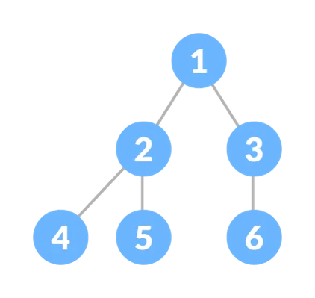

**Complete Binary Tree Properties**

* A perfect binary tree of height *h* has the following property:
  + There are **between** 2*h* and 2*h*+1 − 1 nodes at height *h*
* This implies that the height of a complete binary tree is ⌊log *N*⌋, which is clearly *O*(log *N*).
* This property is especially true when using the total height of the tree *h* to try and find the number of leaves a binary tree has.

**Example**

* We can say for certain that this complete binary tree with height 3 has between 23 and 23+1 - 1 nodes.
* This means that the tree can have between 8 and 15 nodes, which holds to be true.
* H is the first possible node that holds the completeness property at level 3, and 15 is the rightmost node we could put in the tree at height 3.

8th node

15th node at rightmost part of tree.

